Case 2-A344-ME-Syro-Hittite-Astarte-Terracotta-Late Bronze Age-1500 - 1200 BCE 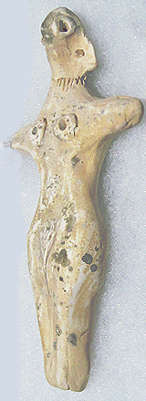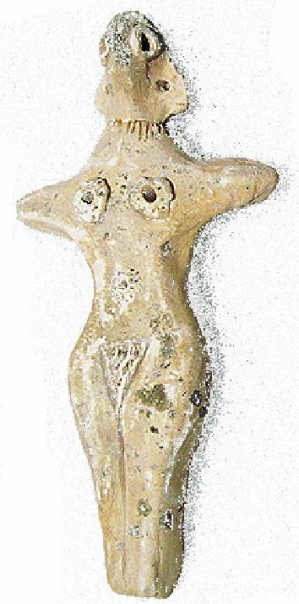 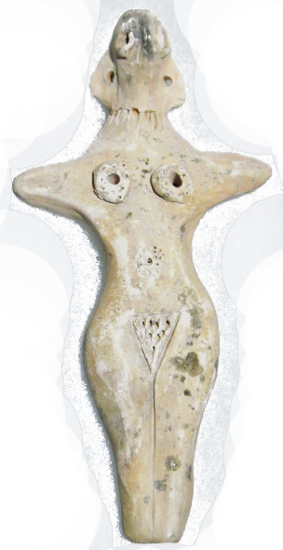

**Figs. 1-3.** Syro-Hittite-Astarte-Figurine-Terracotta-Late Bronze Age-1500 - 1200 BCE

**Case no.: 3**

**Accession Number: A344**

**Formal Label:** Syro-Hittite-Astarte-Figurine-Terracotta-Late Bronze Age-1500 - 1200 BCE

**Display Description:**

This stylized female avian-anthropomorphic figurine has a cylindrical nude human body and has many anthropomorphic attributes such as two short arms perpendicular to the main body at its sides, a relatively flat violin-shaped body, and earrings. A ring of incisions around the neck purports to be a necklace. However, the face is dominated by a raptorial beak suggestive of the practice of excarnation that takes place with the deceased at the scaffolding of the body. (cf. Spycket, A., Borowski Collection, 2000, Cat. no. 84, p. 102, (photograph, p. 101), for the type with long arms; Keel, O., Freiburg, 2008, p. 23, fig 3).

with long arms; Keel, O., Freiburg, 2008, p. 23, fig 3).

**LC Classification:** BL1605 A5

**Date or Time Horizon:** Late Bronze Age-1500 - 1200 BCE

**Geographical Area:** N Syria, S Anatolia.

**Map, GPS coordinates:** N Syria, S Anatolia

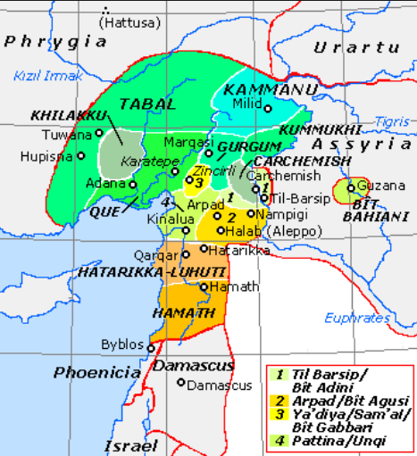

**Fig. 4.** Map of Luwian-, Aramaic- and Phoenician-speaking political entities of the the Syro-Hittite states in northern Syria and southern Anatolia from https://upload.wikimedia.org/wikipedia/commons/f/fe/NeoHittiteStates.gif.

**Cultural Affiliation:** Syro-Hittite

**Medium:** Terracotta

**Dimensions:** H. 13.4 cm., 5 1/4 in

**Weight: 69 gm, 2 3/8 oz**

**Condition: original**

**Provenance:** Ex. Private collection 1980's; Gideon Sasson, Sasson Ancient Art, King David Hotel - Annex, Jerusalem - 94101,  Israel.

**Discussion:**

**References:**

Cornelius, Izak. 2004. *The many faces of the goddess: the iconography of the Syro-Palestinian goddesses Anat, Astarte, Qedeshe.* Fribourg, Switzerland: Academic Press; Göttingen: Vandenhoeck & Ruprecht.

Keel, O. 2008. *Gott weiblich: Eine verborgene Seite des biblischen Gottes, Gutersloher Verlagshaus*. Freiburg.

Spycket, A. 2000. *The Human Form Divine. From the Collection of Elie Borowski,* Exh. cat., Jerusalem: Bible Lands Museum.